Project Design Phase-II
Data Flow Diagram & User Stories
Date | 03 October 2026
Team ID | SWTID-2026-8647
Project Name | Implement Client Script & UI Policy (Incident)
Maximum Marks | 4 Marks

Data Flow Diagrams:

A Data Flow Diagram (DFD) is a traditional visual representation of the information flows within a system. For this project, the DFD shows how Incident information moves through the ServiceNow form, UI Policy, dynamic field behavior, Client Script validation, and the Incident record.

Example: (Simplified)
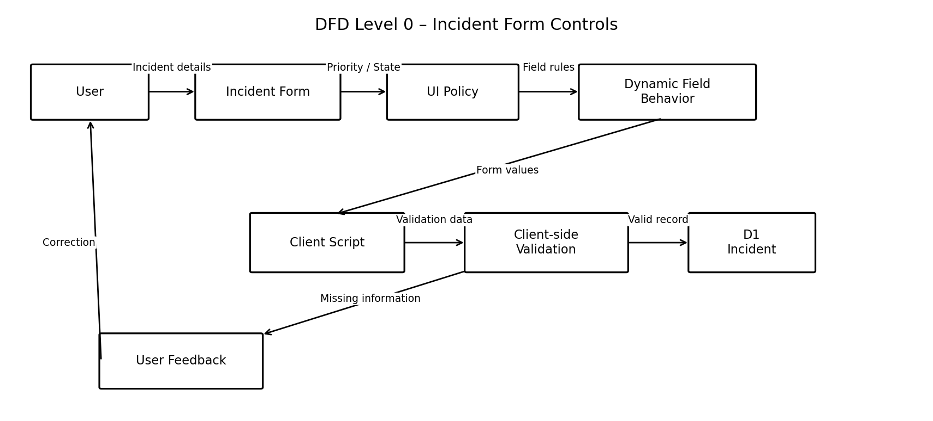

User Stories:

Use the below template to list all the user stories for the product.

User Type | Functional  Requirement (Epic) | User Story  Number | User Story / Task | Acceptance criteria | Priority | Release
Customer  (ServiceNow user) | Incident Creation | USN-1 | As a user, I can create an Incident record and enter the required Incident information. | I can open the Incident form and enter Incident details. | High | Sprint-1
 | Dynamic Form Behavior | USN-2 | As a user, I can see Incident fields change according to the configured Priority and State conditions. | Relevant fields become mandatory, visible, or read-only when the condition is satisfied. | High | Sprint-1
 | Critical Incident | USN-3 | As a user, I can provide the required Assignment Group and Short Description for a critical Incident. | Required fields are clearly indicated on the Incident form. | High | Sprint-1
 | User Feedback | USN-4 | As a user, I can receive feedback when required Incident information is missing. | The form identifies the missing information before the user proceeds. | High | Sprint-1
Customer Care  Executive | Incident Review | USN-5 | As a Customer Care Executive, I can review Incident details using the controlled Incident form. | Incident information is presented according to the configured form behavior. | Medium | Sprint-2
 | Incident Update | USN-6 | As a Customer Care Executive, I can update Incident Priority or State and observe the configured field behavior. | The form responds to the configured Incident condition. | Medium | Sprint-2
 | Submission | USN-7 | As a Customer Care Executive, I can submit an Incident after the required information has been provided. | A valid Incident can proceed without missing required information. | High | Sprint-2
Administrator | UI Policy | USN-8 | As an administrator, I can create a UI Policy for the Incident table. | The UI Policy contains the required condition and is active. | High | Sprint-1
 | UI Policy Actions | USN-9 | As an administrator, I can configure UI Policy Actions for Incident fields. | Field mandatory, visible, and read-only behavior is configured as required. | High | Sprint-1
 | Client Script | USN-10 | As an administrator, I can configure a Client Script for the Incident table. | The Client Script has the required type, UI Type, application, and execution timing. | Medium | Sprint-2
 | Validation | USN-11 | As an administrator, I can configure client-side validation behavior for required Incident information. | The configuration supports feedback when required information is incomplete. | Medium | Sprint-2
 | Testing & Maintenance | USN-12 | As an administrator, I can verify and maintain the Incident form configuration. | The configuration can be checked using different Incident conditions and updated when requirements change. | Low | Sprint-3

